The research is part of the European project “FlexRICAN” which is conducting in collaboration with two laboratories in Grenoble G2Elab and G-SCOP. It is focused on accurately modeling the actions of households (multi-agent simulation) in response to various signals to evaluate and enhance energy flexibility in residential buildings.

At the very beginning of the work, I researched about bibliography and tried to find relevant references to see what is going on in this subject nowadays and have a global overview of the topic. We agree with my supervisors Stephane and Frederic that we could work with real data which is 100 houses' actual consumption in France in different regions. This data shows the electrical consumption of each energy appliance with a time step of 10 min, and also shows total site consumption, additionally, we can see locations and weather conditions for the period of recording time. I am also using the building energy simulation defined by Professor Stephane Plox.

Initially, I cleaned data and made it ready for analysis by using Python coding language. Data cleaning consists of different steps. Since the data is very old from 1998 -2000 years, it contains a lot of missing values or errors in sensors, to avoid these problems I used "dropna" and "fillna" methods which will drop or fill necessary values. Also, I removed duplicates in case there was any, fixed datatype because data was given in different formats, I detected outliers and tried to clean data from them, and then I filtered unnecessary data, finally I got 90 houses which were more or less accurate to work on. another problem was starting and ending data were different for each house, and for equal analysis, we needed to reconcile somehow. For this, I decide to filter all data for 1 year. Finally, I got accurate data to work on.

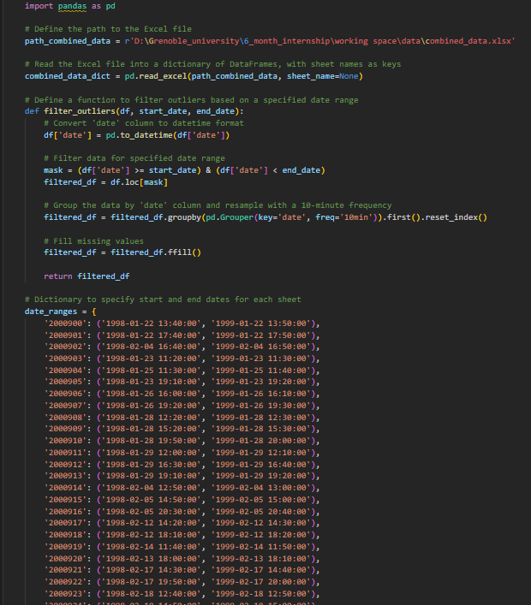 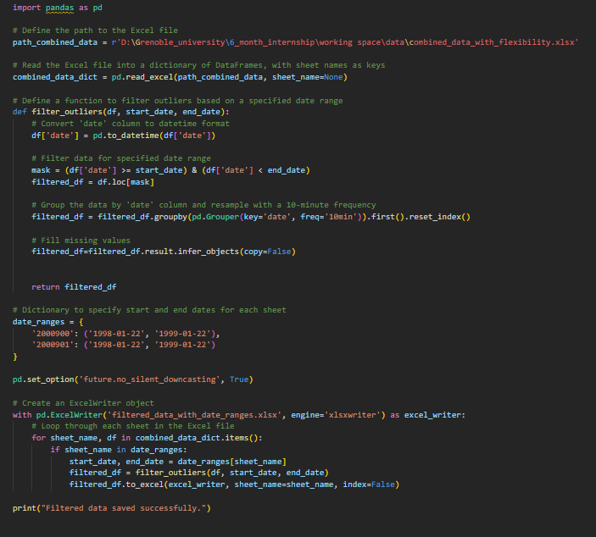

Filtering data for one year

From the cleaned data I took all the house's energy appliances, to know what appliances they have, there were 29 appliances distributed differently in each house. And I give them flexibility conditions whether they can be flexible or not. I defined them after researching and reading papers about flexibility and flexible devices and after I agreed with the supervisors. The idea is to know which devices in which houses can be flexible to define the potential of flexibility. Then I used this information to give flexibility status for each appliance in full data for 90 houses. This way I can know how much is flexible and not flexible consumptions for each house.

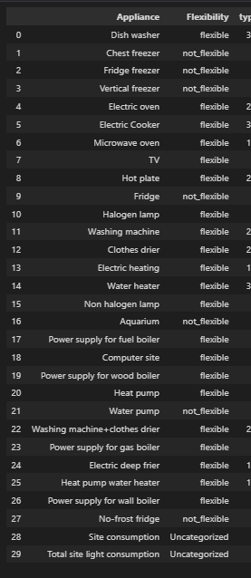 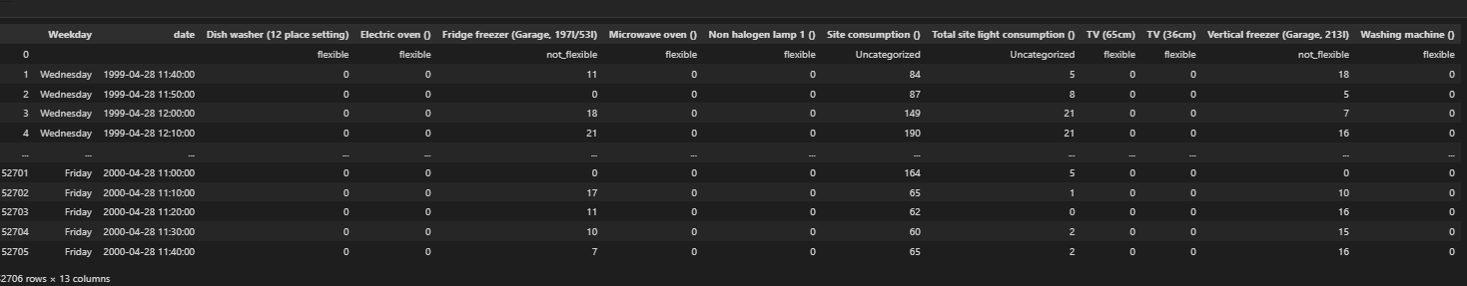

Flexibility conditions for energy appliances for each house.

We decided to have flexibility indicators for simulation, for this, we needed to know the full potential of flexibility in order to calculate simple (which does not require complex and expensive information) and complex (which requires complex and expensive information) indicators.

Simple indicators: for simple indicators, the basic idea is to know only the names of appliances which are in each dwelling, this information is not complex to gather, also I did research about all possible appliance's average power in France and average annual energy consumption according to agirpourlatransition.ademe.fr/.

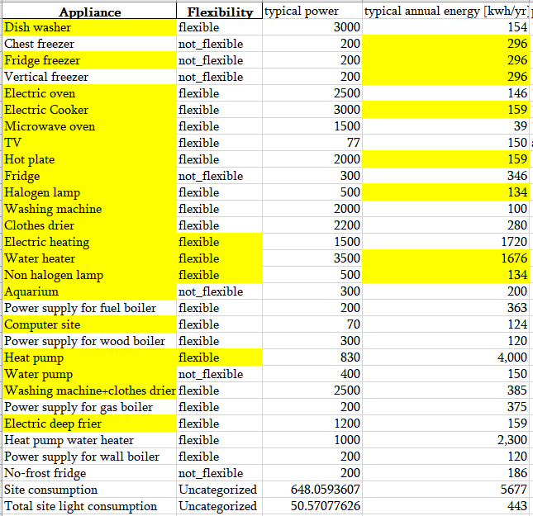

Average annual power and annual energy consumption

First, I tried to identify which devices are more interesting according to their power and which devices are interesting according to their energy consumption, mostly interesting is annual energy consumption because for example fridge does not have high power but it is always working and it consumes more energy than an oven for example which power is almost 10 times more but we use 10 times less.

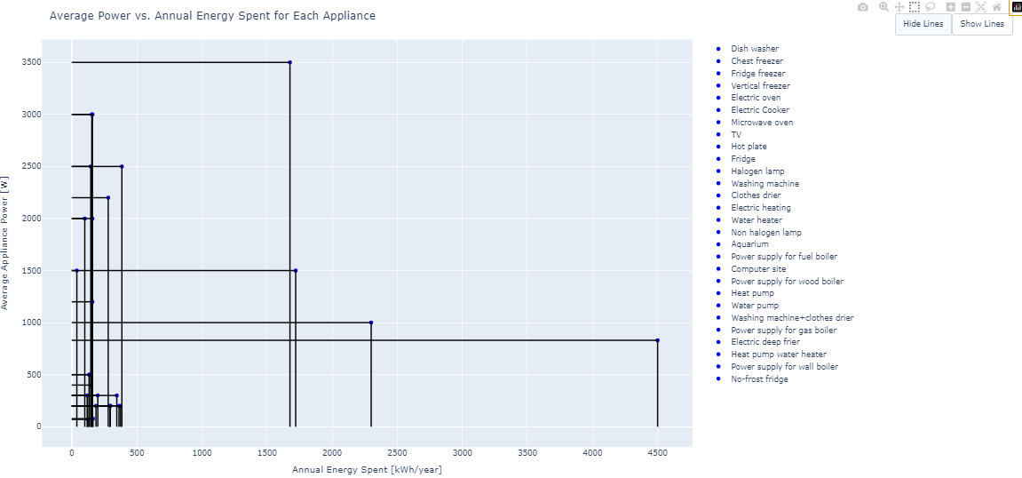

Power vs energy

With this basic information, I defined the flexibility indicator which is $\frac{flexible power}{total power}$ and $\frac{flexible annual energy}{total annual energy}$.

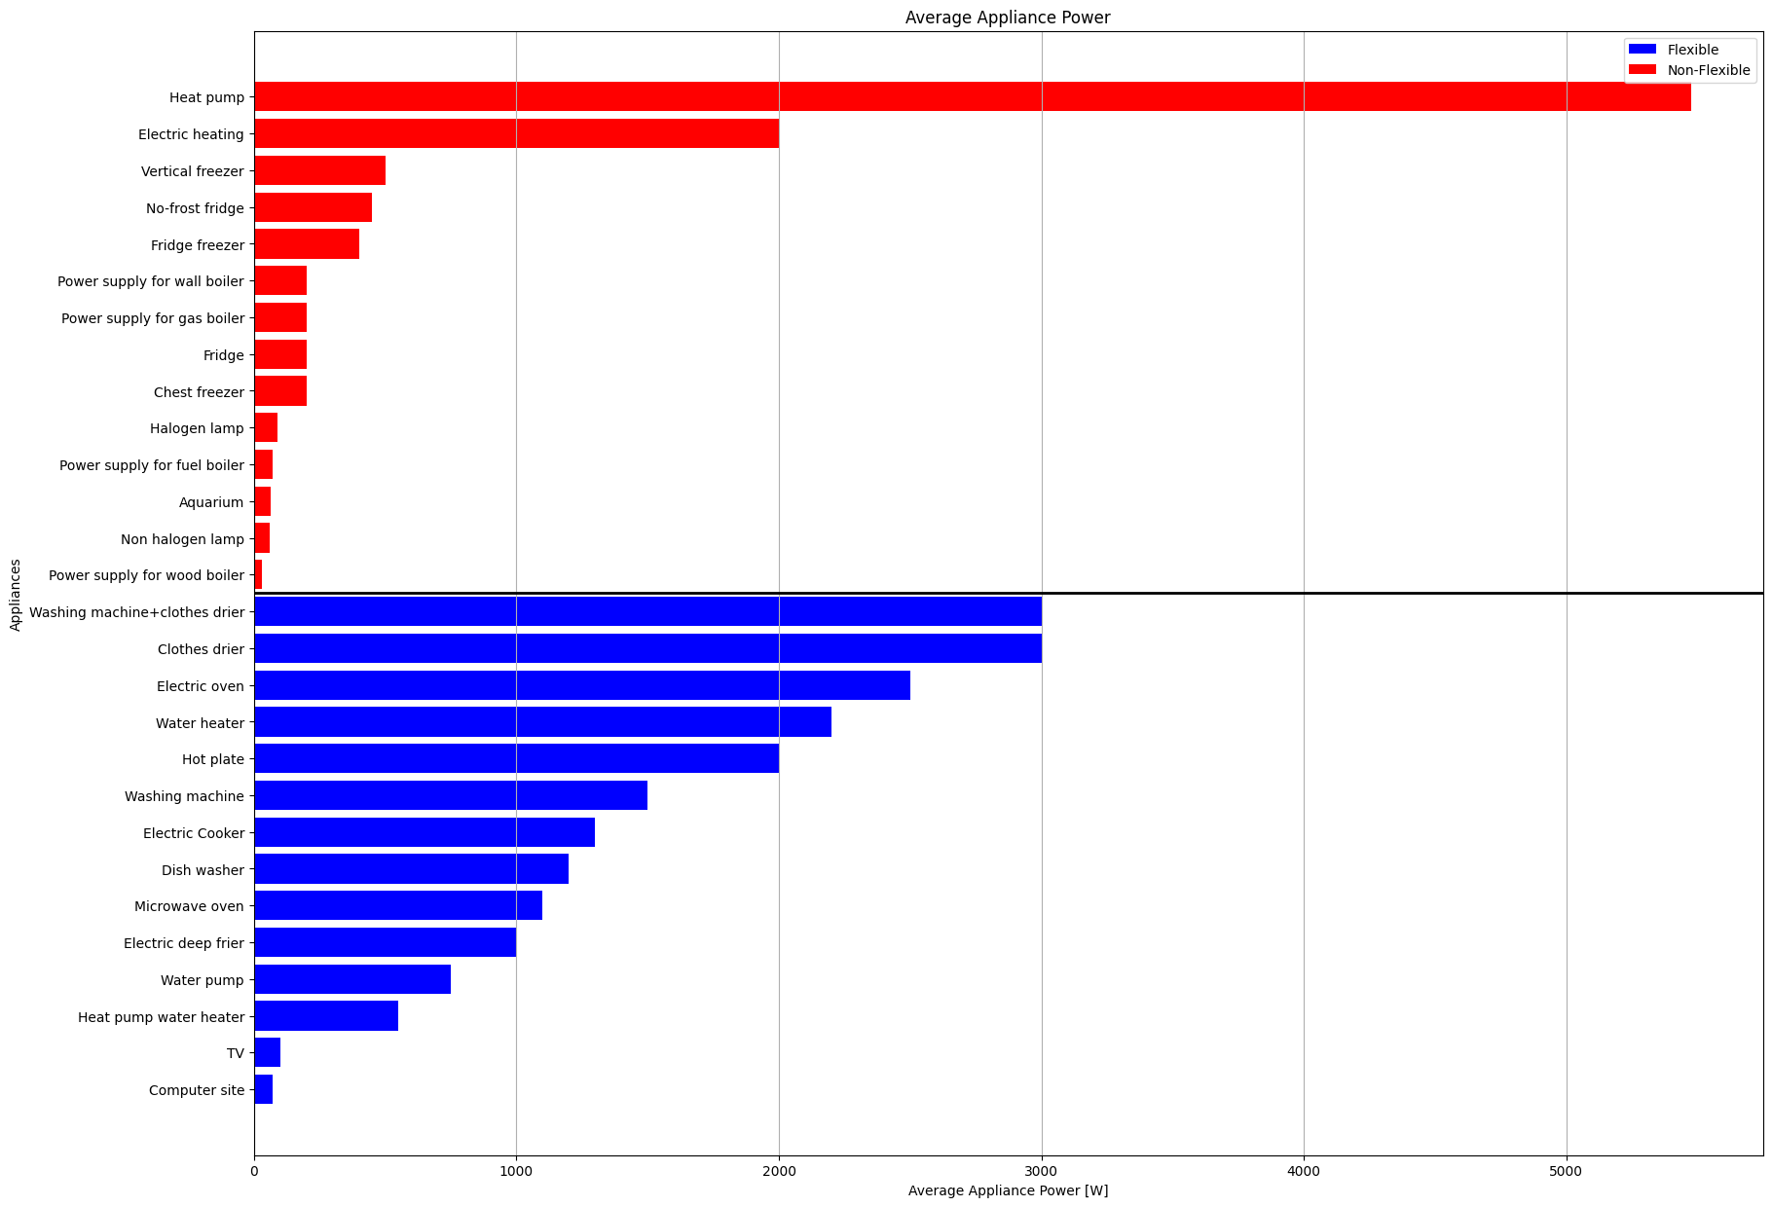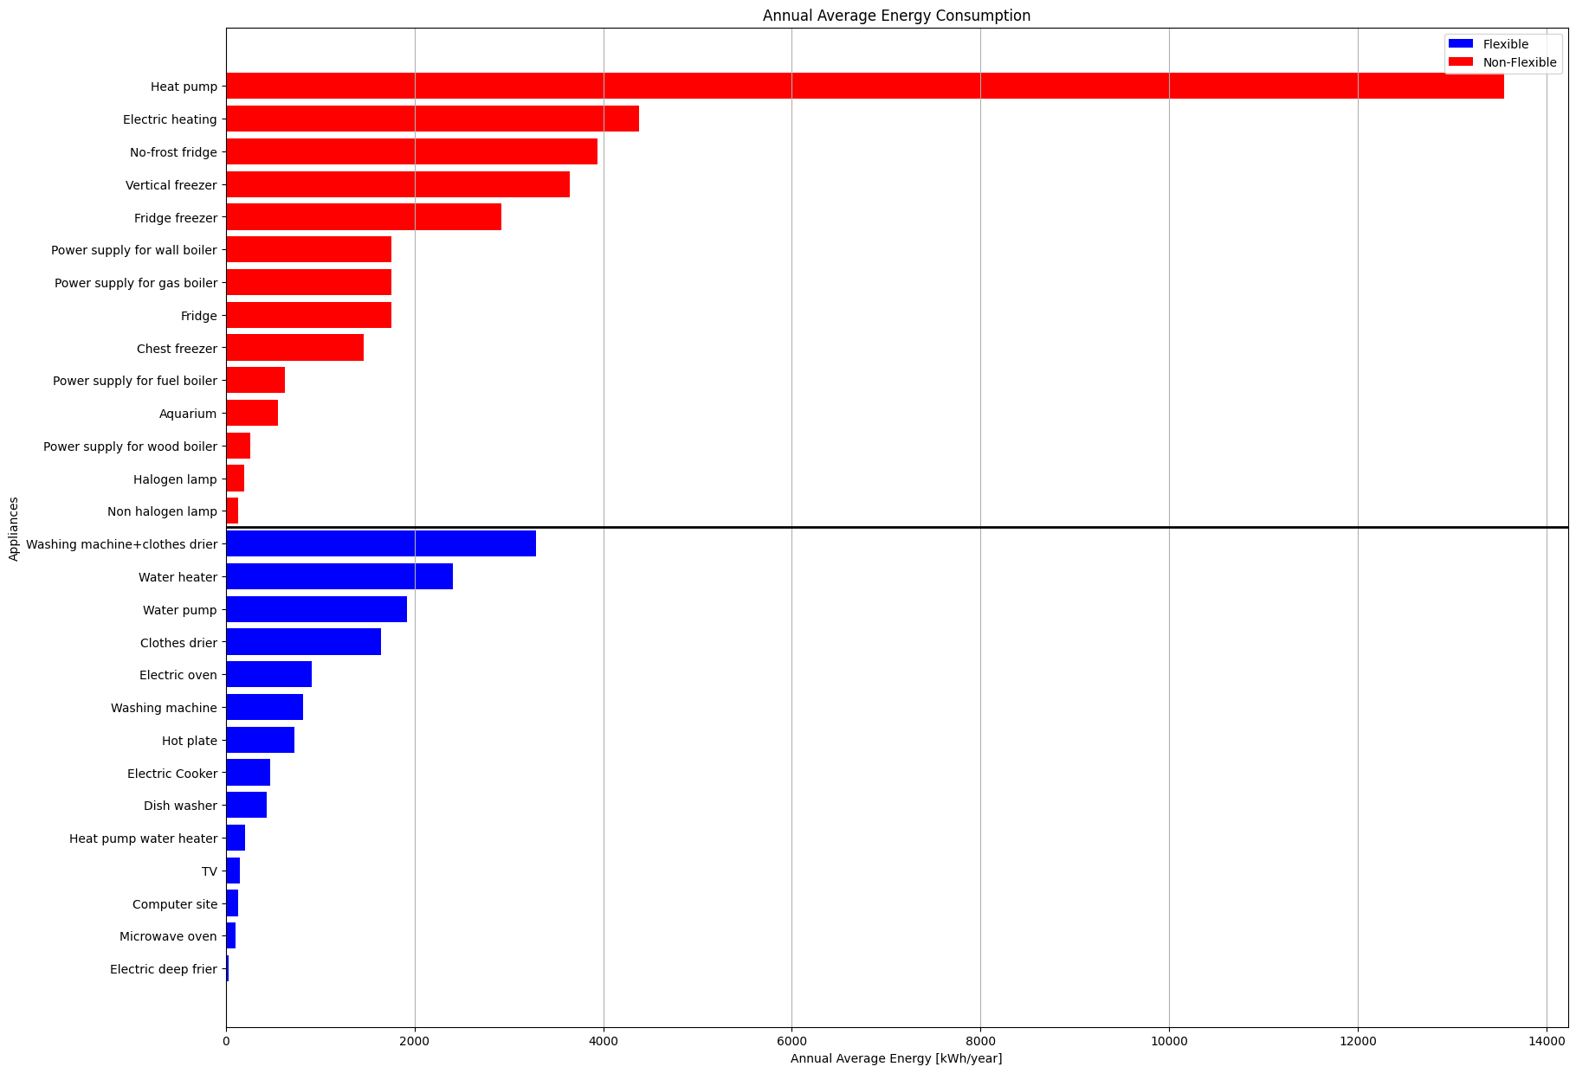

Annual average energy and average power

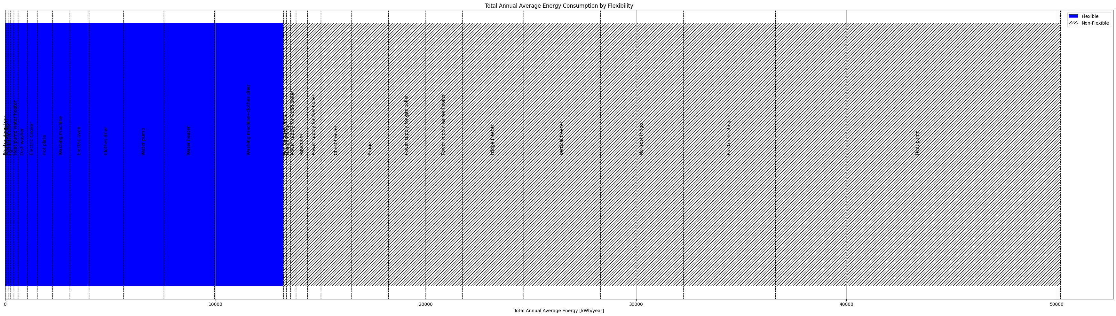

Flexible vs not flexible annual average energy

Next, I am going to work on complex indicators that contain information from sensors about energy consumption for each house and then I am going to compare these two to each other and see how precise can I be with less information.